**IDENTITY ACCESS MANAGEMENT**

**Use your AWS account email address and password to sign in as the**[***AWS account root user***](http://docs.aws.amazon.com/IAM/latest/UserGuide/id_root-user.html)**to the IAM console at**[**https://console.aws.amazon.com/iam/**](https://console.aws.amazon.com/iam/)**. In IAM click on create individual IAM users -.Manage users**

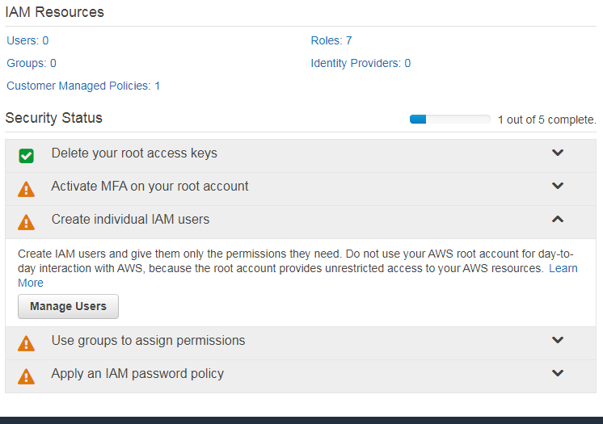

**Add new user**

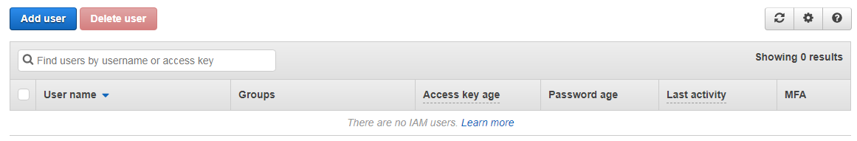

**Select what kind of access should be given to the user. Programmatic access/AWS management console access/both, password and click next**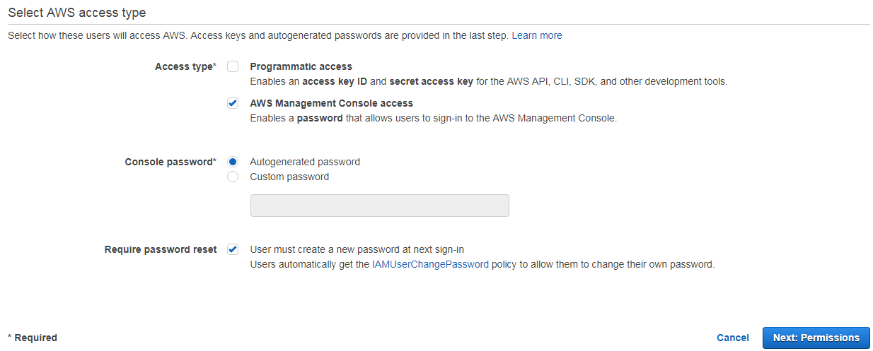

**Now set permissions for your user. Add user to a group by creating a new group** 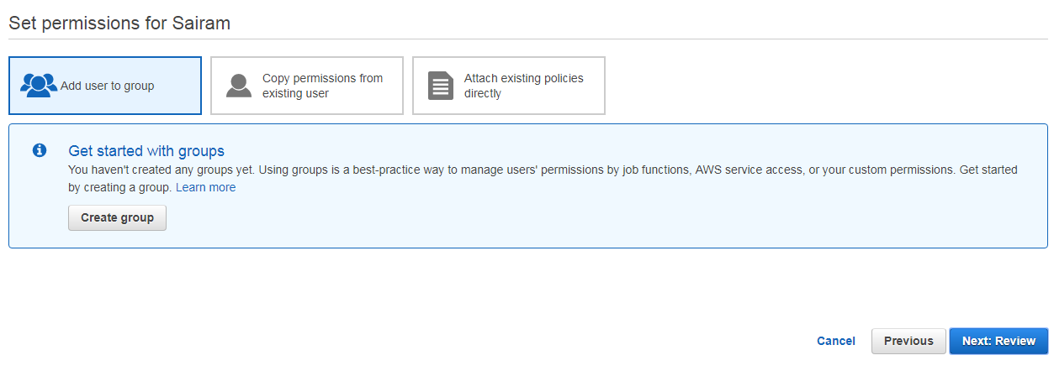

**Select the list of access you need to give to the group by clicking on policy name**

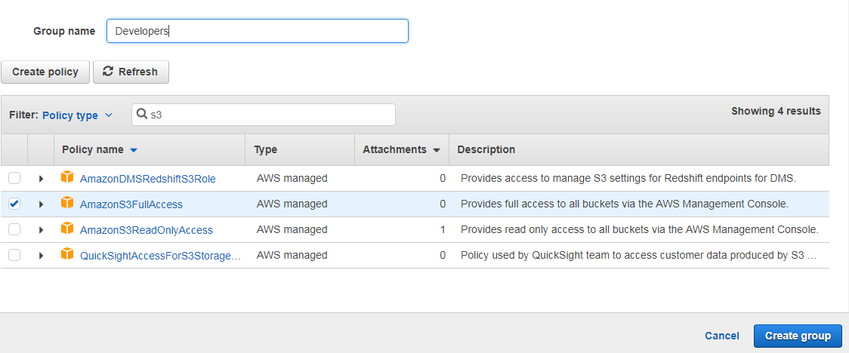

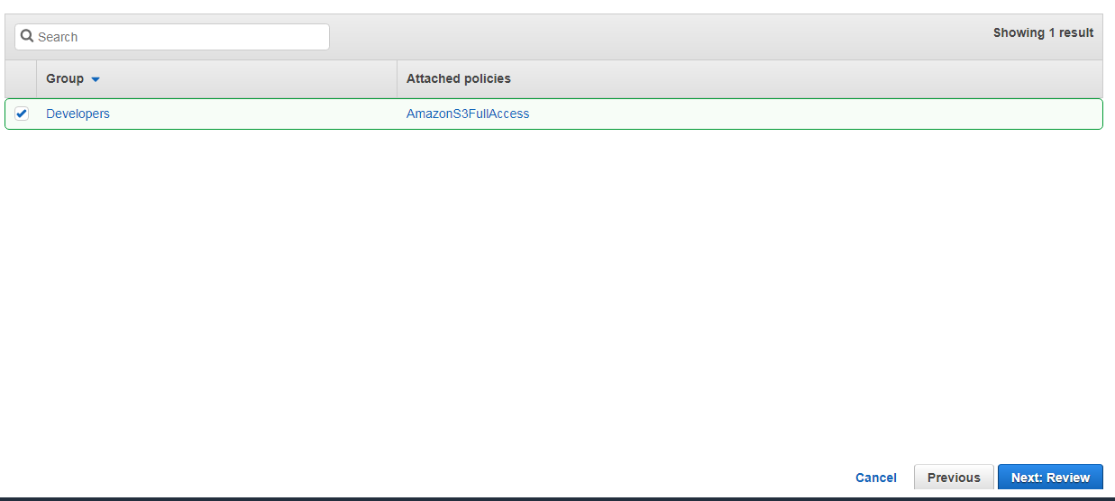

**Review the user details and permissions summary and create user**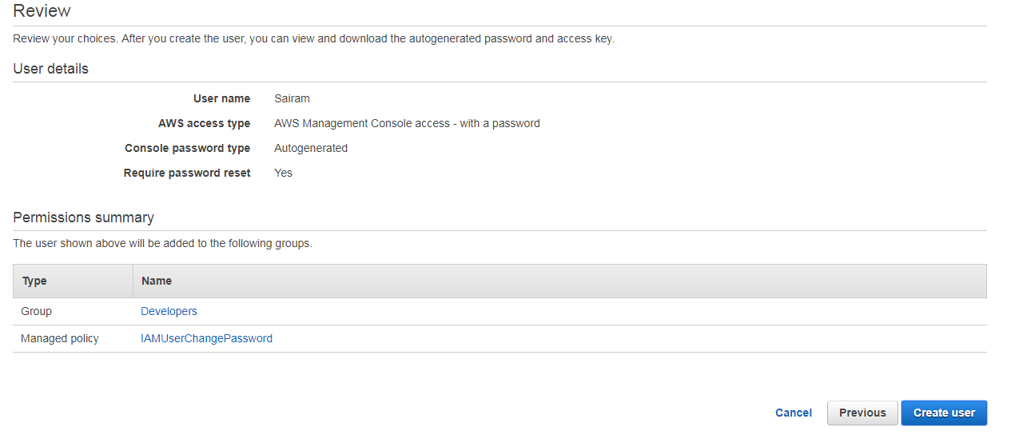

**User is created. Give show password and save the password for future**

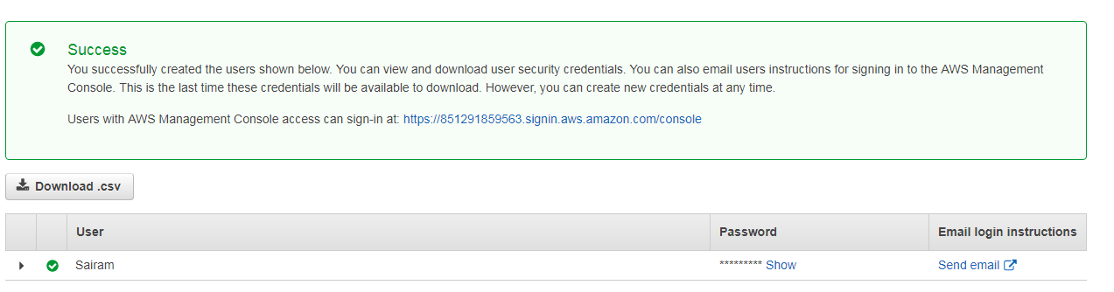

**Apply an IAM policy password**

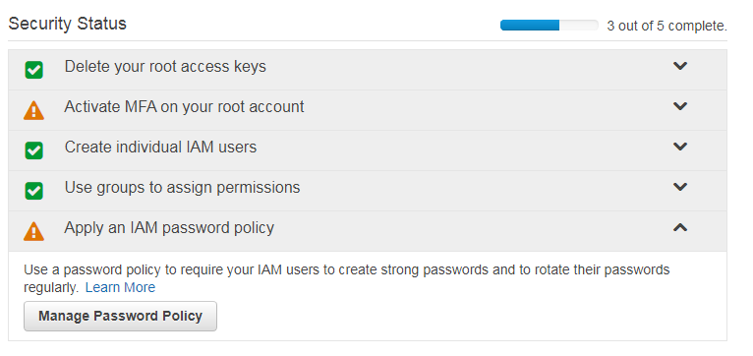

**Apply password policy**

